**Assignment-2**

|  |  |
| --- | --- |
| Date | 06 October 2022 |
| Team ID | PNT2022TMID47827 |

**Question-1**

Consider a list(list=[ ]).You can perform the following commands:

insert i e: Insert integer at position

print: Print the list

remove e: Delete the first occurrence of integer

append e: Insert at the end of the list

sort: Sort the list

pop: Pop the last element from the list

reverse: Reverse the list

Initialize your list and read in the value of followed by lines of commands where each command will be of the types listened above. Iterate through each command in order and perform the corresponding operation on your list.

**Solution:**

list = [int(x) for x in input().split()]

print("Initialized list: ", list)

list.insert(3, 4)

print("Inserting 4 at index 3: ", list)

list.remove(4)

print("Removing value 4: ", list)

list.append(60)

print("Appending 60: ", list)

list.sort()

print("Sorting: ", list)

x = list.pop()

print("Pop out last element: ", list)

list.reverse()

print("Reversing: ", list)

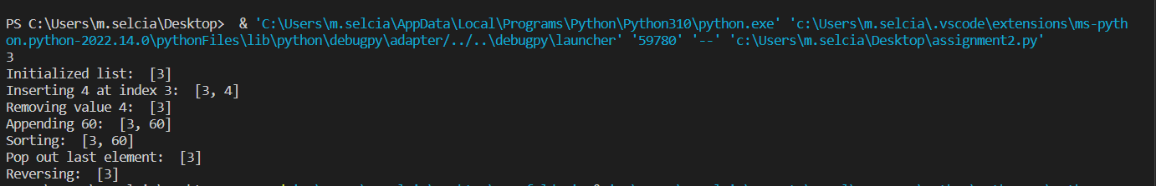

**Question-2**

a)Write a calculator program in Python.

Solution:

x = float(input("Enter number1: "))

op = input("Enter operator: ")

y = float(input("Enter number2: "))

def calc(a, b, op):

if(op == "+"):

return a+b;

elif(op == "-"):

return a-b;

elif(op == "*"):

return a*b;

elif(op == "/"):

return a/b;

elif(op == "%"):

return a%b;

else:

return "Invalid operation!"

res = calc(x, y, op)

print(x, op, y, " = ", res)

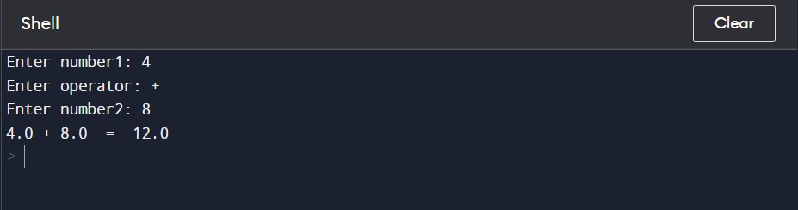

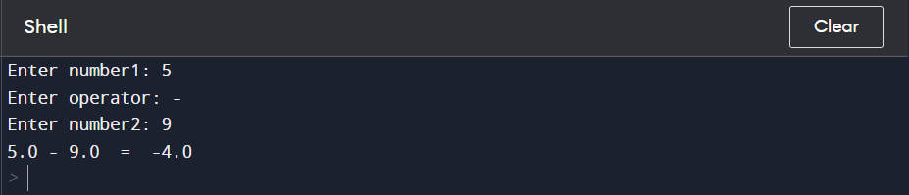

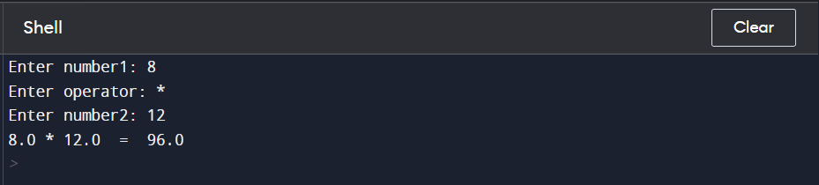

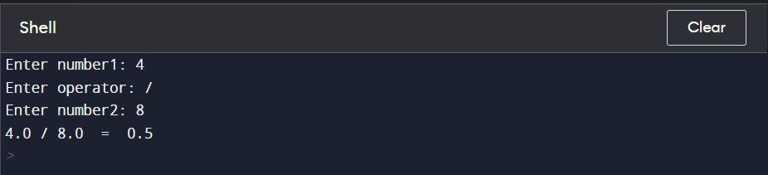

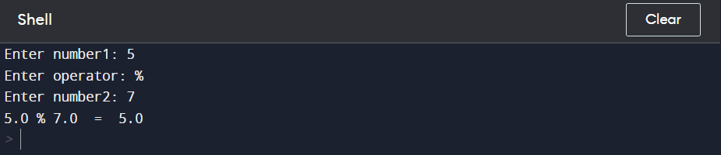

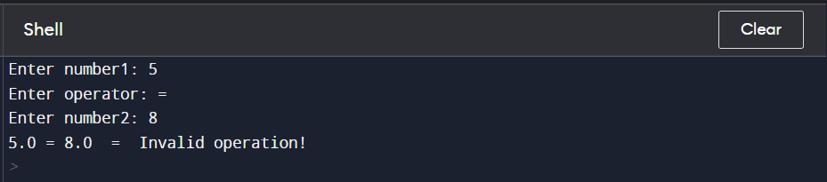

b)Write a program to concatenate,reverse and slice a string.

Solution:

s1 = "employee"

s2 = "manager"

print("String concatenation: ", s1+s2)

print("Reversed string: ", s1[::-1])

print("String slice:\n\ts1[7:12] = ", s1[7:12], "\n\ts2[0:4] = ", s2[0:4])

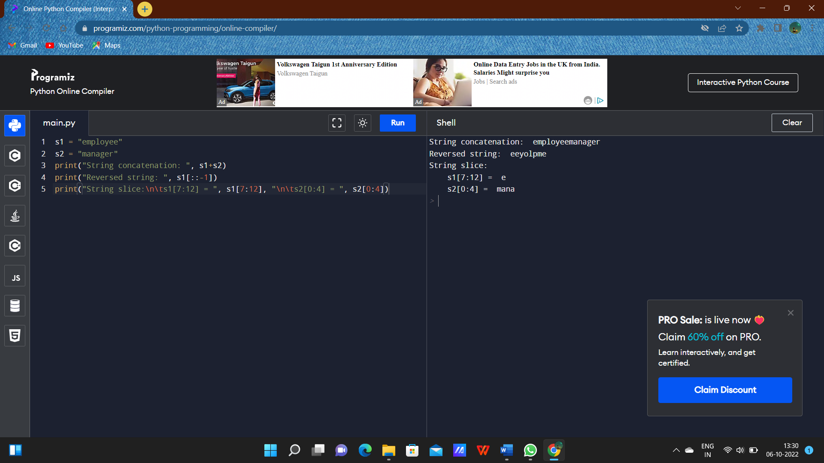

c)Why is Python popular programming language?

* The python language is one of the most accessible programming languages available because it has simplified syntax and not complicated, which gives more emphasis on natural language.
* Due to its ease of learning and usage, python codes can be easily written and executed much faster than other programming languages.

d)What are the other frameworks that can be used with Python?

1.**Flask** : It is a micro-framework for Python. It is lightweight and easily adaptable to suit a developer’s needs.

2.**Django** : It is a popular open-source full-stack Python framework that includes all the necessary Python features by default.

3.**Web2Py** : It is another popular open-source and full-stack Python framework. It is platform-independent, which means that it can run on all the popular operating systems.

4.**Bottle** : It is a micro-framework for prototyping and building simple personal applications. It was originally meant for building APIs and is considered by developers as one of the finest Python web frameworks.

e)Full form of WSGI.

* Web Service Gateway Interface.
* It is an interface between web servers and web apps for Python.